**Plant Pathogenomics**

Training School of the COST Action SUSTAIN

on

Genomics of Plant Pathogens

April 7th, 2017 in Norwich, United Kingdom

**DAY 5**

“Using field patho-transcriptomics to capture (natural) diversity and differential expression of

virulence and resistance genes   
of the oomycete *Hyaloperonospora crispula* and

its host plant *Reseda luteola*”

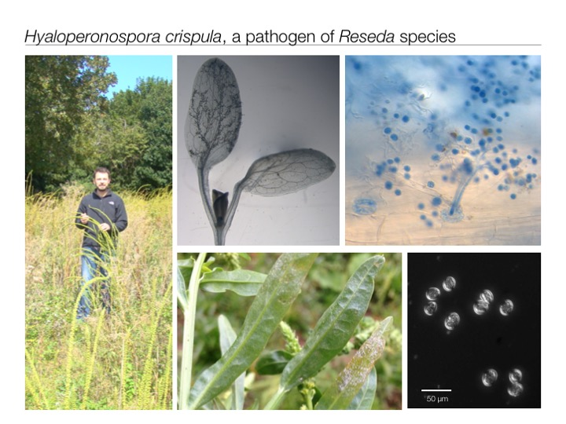

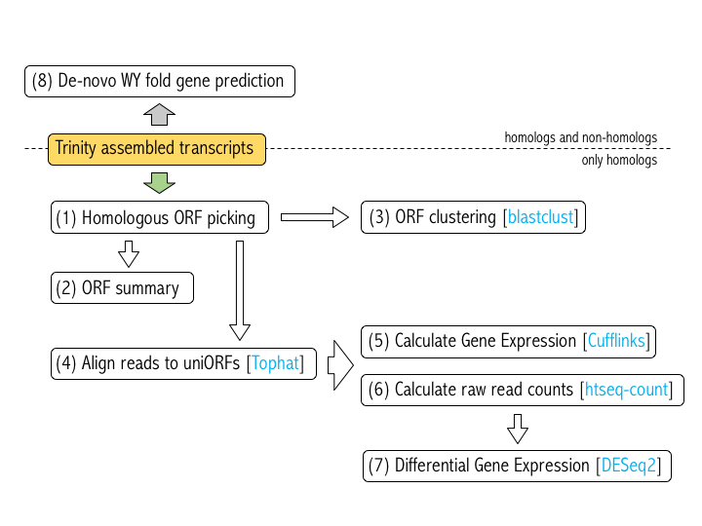**# Pipeline Overview**

**# Samples Summary**

|  |  |  |  |  |
| --- | --- | --- | --- | --- |
| **Samples** | **Infection symptoms** | **Illumina paired reads after quality filtering** | **Nr. of Trinity assembled transcripts** | **Contig lengths** |
| Hpc2-1 | Infected | 64,203,475 | 166,069 | 201-21,110 |
| Hpc3-1 | Infected | 55,651,860 | 122,329 | 201-19,800 |
| Hpc4-2 | Infected | 58,047,599 | 128,155 | 201-24,110 |
| Reseda1-3 | Non-Infected | 47,969,359 | 99,794 | 201-15,630 |
| Reseda2-1 | Non-Infected | 48,541,072 | 105,203 | 201-15,560 |
| Reseda3-1 | Non-Infected | 58,939,583 | 101,113 | 201-17,160 |

**# Create working directory structure**

**cd /home/student1/**

**mkdir Day5**

**cd Day5/**

**mkdir 00\_Scripts 01\_Data 02\_ORFsummary 03\_OTUpicking 04\_Mapping** **05\_DiffExpress**

**# Download Data and Scripts from Github**

Download “Day5\_data” from Github **to the** **01\_Data** folder that you created before following the link:

https://github.com/SUSTAIN-COST-Action-Norwich/Day5\_data

**!!! Unzip all files!!!**

Download “Day5\_scripts” from Github **to the** **00\_Scripts** folder that you created before following the link:

https://github.com/SUSTAIN-COST-Action-Norwich/Day5\_scripts

**# (1) Identify homologous full-length ORFs in Trinity assemblies using Tblastn search and filtering the results for 1st hit full length ORFs.**

Use related species (*Hyaloperonospora arabidopsidis* and *Arabidopsis thaliana*) as tblastn queries to search Trinity assemblies.

**cd 01\_Data**

Create the database for blast search:

**makeblastdb –in Trinity.fasta –dbtype nucl**

Use tblastn to find hits to known sequences:

**tblastn –db Trinity.fasta –query Arabidopsis\_TAIR10.faa –out Arabidopsis\_tbn\_Trinity\_fasta\_out.txt –outfmt 0 –evalue 0.0001**

**tblastn –db Trinity.fasta –query** **Hpa\_v8.3.faa –out hpa\_tbn\_Trinity\_fasta\_out.txt –outfmt 0 –evalue 0.0001**

Use custom perl scripts to extract the 1st hit full-length ORFs from tblastn outputs:

**perl /home/student1/Day5/00\_Scripts/find\_all\_full-length\_hits.pl Arabidopsis\_tbn\_Trinity\_fasta\_out.txt > arabidopsis\_fl\_hits.txt**

**perl /home/student1/Day5/00\_Scripts/extract\_orf.pl arabidopsis\_fl\_hits.txt Trinity.fasta reseda\_orfs.fasta**

Example for tblastn output format 0 (-outfmt 0):

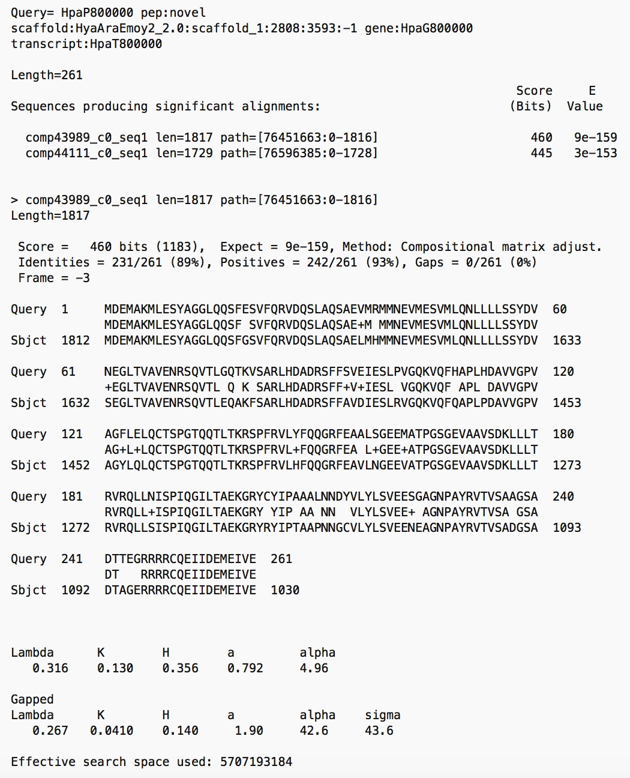

**# (2) ORF SUMMARY**

# Run R script ORFsummary.R to plot ORF length distribution and create a fasta file with all unique ORFs and a corresponding gtf file for later read mapping steps

**cd /home/student1/Day5**

**R CMD BATCH 00\_Scripts/ORFsummary.v2.R**

Outputs:



uniORFs.fasta

uniORFs.gtf

plantORFsF.txt

pathogenORFsF.txt

uniORFsummary.txt # tab-delimited table summarising

**# (3) Cluster all unique ORFs into operational taxonomic units (OTUs) using blastclust**

https://www.ncbi.nlm.nih.gov/books/NBK279690/

Clustering of unique ORFs into OTUs based on length coverage and sequence similarity

-i <input file>

-o <output file>

-p input sequence format: T (protein) F (nucleotide)

-L Length coverage threshold (0 - 1)

-S Sequence similarity (0 - 100)

-b apply to each sequence?

**cd /home/student1/Day5**

**blastclust -i 04\_Mapping/uniORFs.fasta -o 03\_OTUpicking/uniORFsBlastClust.txt -p F -L 1 -S 98 -b T**

**# 4. READ ALIGNMENT TO ORFs using TOPHAT**

# http://ccb.jhu.edu/software/tophat/manual.shtml

# Index the uniORFs.fasta file for reference usage in Tophat:

See Day 1!

**# 5. Estimation of Gene Expression Levels using CUFFLINKS**

# http://cole-trapnell-lab.github.io/cufflinks/cufflinks/index.html

-g Reference annotation gtf file

-m Expected (mean) fragment length: 250 (default 200)

-s Standard deviation for the distribution on fragment lengths 85 (default 80)

-I Maximum intron length 5000 (default 300000)

–min-intron-length 20 (default 50)

<input file> Tophat output file “uniORFs\_10\_accepted\_hits.bam”

**cd /home/student1/Day5/05\_DiffExpress/**

**cufflinks -g /home/student1/Day5/01\_Data/uniORFs\_10.gtf -m 250 -s 85 -I 5000 --min-intron-length 20 /home/student1/Day5/01\_Data/uniORFs\_10\_accepted\_hits.bam**

Outputs:

genes.fpkm\_tracking # This is the output file of interest with normalised read counts per gene.

isoforms.fpkm\_tracking

skipped.gtf

transcripts.gtf

**# 6. COUNTING READS THAT MAP TO ORFs using htseq-count**

# http://www-huber.embl.de/HTSeq/doc/count.html

Counts reads that map to transcripts using htseq-count

-f Format of input data (default sam)

-r Input file is sorted by read name or alignment position? (default: name)

-m Mode to handle reads overlapping more than one feature (default: union)

-s Whether data is from a strand-specific assay (default: 10)

-a Skip reads with alignment quality lower than the given number (default: 10)

-t Feature type (3rd column in GTF/GFF file) to be used (default: exon)

<alignment file> (sorted accepted\_hits.bam output file from Tophat)

<gtf file> (annotation file)

**cd /home/student1/Day5/**

**htseq-count –f bam –r pos -m intersection-strict -s yes -t CDS 01\_Data/ uniORFs\_10\_accepted\_hits\_sorted.bam 01\_Data/uniORFs\_10.gtf > 05\_DiffExpress/uniORFs\_10\_htseq.tab**

**# 7. DIFFERENTIAL EXPRESSION Analysis using DESeq2**

https://www.bioconductor.org/packages/release/bioc/vignettes/DESeq2/inst/doc/DESeq2.pdf

Run R script DiffExpress.R

**cd /home/student1/Day5/**

**R CMD BATCH 00\_Scripts/DiffExpress.v5.R**

Outputs of the scripts:

RPKMcomparison.pdf (Plot of plant ORF RPKMs between pairs of samples)

**Final/Day5/05_DiffExpress/RPKMcomparison.pdf**

meanRPKMcomparison.Arabidopsis.Hpa.pdf (mean RPKMs of infected and non-infected samples color-coded for plant ORFs (green), pathogen ORFs (grey) and shared ORFs (orange).

Final/Day5/05_DiffExpress/meanRPKMcomparison.Arabidopsis.Hpa.pdf

SampleDistances.pdf (Heatmap of sample to sample distances inferred from regularised log transformation of the original count data to a log2 scale

Final/Day5/05_DiffExpress/SampleDistances.pdf

**Final/Day5/05_DiffExpress/PCA_OTUs.pdf**

PCA\_OTUs.pdf (Principal component analysis of sample read counts)

**Final/Day5/05_DiffExpress/MAplot.pdf**MAplot.pdf (showing the log2 fold changes attributable to a given variable over the mean of normalized counts)

Top20\_up\_down\_regulatedOTUs.padj0.01.csv

Hpc21.plantOTU.csv

Hpc31.plantOTU.csv

Hpc42.plantOTU.csv

Reseda13.plantOTU.csv

Reseda21.plantOTU.csv

Reseda31.plantOTU.csv

**# 8. De-novo WY-fold gene prediction**

Log file for making secretome from ORFs in assembled RNA-seq reads

Starting number of sequences (assembled contigs): **722,663**

Starting number of ORFs (and translations): **6,169,199**

# 4/12/15

Broke up the ORFs to smaller files containing 1,000,000 sequences each to be processed on Linux machine for SignalP2.0

Each file took ~10-14 hours to get processed.

Built another Linux machine and parallel processed the files.

# 8/12/15

Finished all SignalP2.0 runs.

Started on TMHMM2.0c and TargetP1.1 for sequences that passed SignalP2.0 criteria: Prediction = "Signal peptide", HMM score > 0.9, cleaveage site < 40.

Number of sequences that passed SignalP2.0 criteria: **219,785**

# 10/12/15

Finished running TMHMM and TargetP.

Renamed the sequences so that their ID is made up of less than 20 characters.

Wrote a script named "bioperl\_make\_secretome.pl" to parse the output files from these programs to filter the sequences that have already passed SignalP2.0 filtering.

Number of sequences with 1 or more TM = **83,525**

Number of sequences with mitochondria signal peptide = **26,807**

Number of sequences that passed SignalP2.0, TMHMM, and TargetP filtering = **109,453** (this is the number in the final secretome)

# 11/12/15

Tidied up the results and re-instated the sequence names to original version supplied by Ronny.

Ran hmmsearch like so:

hmmsearch3 WY\_fold.hmm HpcReseda\_pex\_noTM\_noMito\_109453.fasta > HpcReseda\_pex\_noTM\_noMito\_109453\_hmmsearch\_WY-fold.output

There are at least **120** sequences with detectable WY-fold within **109,453** sequences.

Final secretome fasta file and output from WY-fold search were uploaded to Dropbox.